1 run......

training 1 epoch...

102.04903244972229 seconds used......

1 training finished! average train loss: 1.4472064465029626

total clf loss: 149.96332578361034 total adv loss: 94.34149117022753

evaluating...

Confusion matrix, without normalization

[[ 10 103 77]

[ 9 335 71]

[ 8 60 645]]

Normalized confusion matrix

[[0.05263158 0.54210526 0.40526316]

[0.02168675 0.80722892 0.17108434]

[0.0112202 0.08415147 0.90462833]]

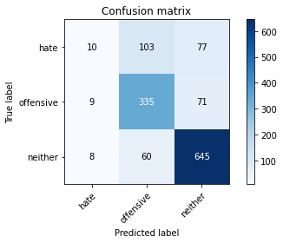

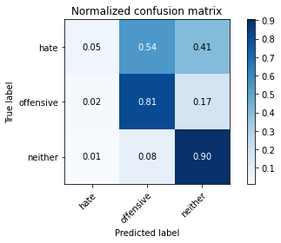

precision recall f1-score support

hate 0.37 0.05 0.09 190

offensive 0.67 0.81 0.73 415

neither 0.81 0.90 0.86 713

accuracy 0.75 1318

macro avg 0.62 0.59 0.56 1318

weighted avg 0.71 0.75 0.71 1318

average eval_loss: 0.6218401902552807, accuracy: 0.7511380880121397

training 2 epoch...

102.0248773097992 seconds used......

2 training finished! average train loss: 1.024360151690805

total clf loss: 109.38109228014946 total adv loss: 65.15959145501256

evaluating...

Confusion matrix, without normalization

[[ 13 108 69]

[ 3 344 68]

[ 11 82 620]]

Normalized confusion matrix

[[0.06842105 0.56842105 0.36315789]

[0.00722892 0.82891566 0.16385542]

[0.01542777 0.11500701 0.86956522]]

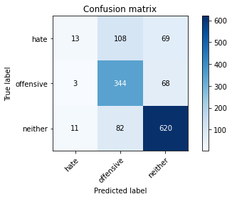

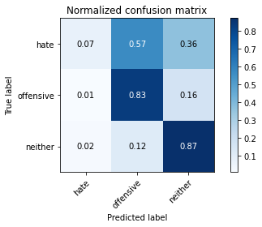

precision recall f1-score support

hate 0.48 0.07 0.12 190

offensive 0.64 0.83 0.72 415

neither 0.82 0.87 0.84 713

accuracy 0.74 1318

macro avg 0.65 0.59 0.56 1318

weighted avg 0.72 0.74 0.70 1318

average eval_loss: 0.6727585634498885, accuracy: 0.7412746585735963

training 3 epoch...

102.00078463554382 seconds used......

3 training finished! average train loss: 0.6642127965505307

total clf loss: 76.44268271327019 total adv loss: 39.491555844433606

evaluating...

Confusion matrix, without normalization

[[ 43 83 64]

[ 17 326 72]

[ 29 58 626]]

Normalized confusion matrix

[[0.22631579 0.43684211 0.33684211]

[0.04096386 0.78554217 0.17349398]

[0.04067321 0.08134642 0.87798036]]

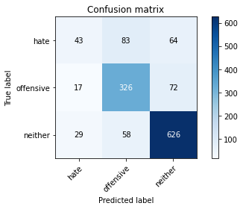

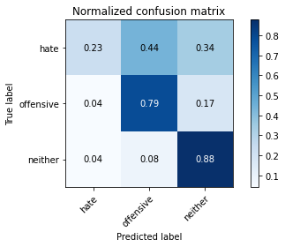

precision recall f1-score support

hate 0.48 0.23 0.31 190

offensive 0.70 0.79 0.74 415

neither 0.82 0.88 0.85 713

accuracy 0.75 1318

macro avg 0.67 0.63 0.63 1318

weighted avg 0.73 0.75 0.74 1318

average eval_loss: 0.7379519307252133, accuracy: 0.7549317147192717

training 4 epoch...

102.07556414604187 seconds used......

4 training finished! average train loss: 0.36188974642218685

total clf loss: 48.401976969093084 total adv loss: 18.140111909160623

evaluating...

Confusion matrix, without normalization

[[ 80 52 58]

[ 58 296 61]

[ 77 27 609]]

Normalized confusion matrix

[[0.42105263 0.27368421 0.30526316]

[0.13975904 0.71325301 0.14698795]

[0.10799439 0.03786816 0.85413745]]

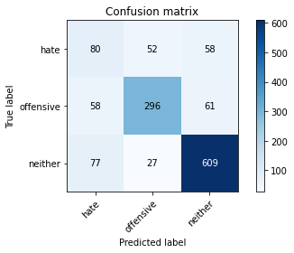

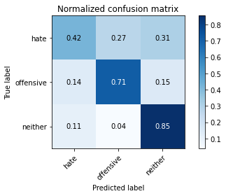

precision recall f1-score support

hate 0.37 0.42 0.40 190

offensive 0.79 0.71 0.75 415

neither 0.84 0.85 0.85 713

accuracy 0.75 1318

macro avg 0.67 0.66 0.66 1318

weighted avg 0.75 0.75 0.75 1318

average eval_loss: 0.8181063923420329, accuracy: 0.7473444613050075

training 5 epoch...

102.01161932945251 seconds used......

5 training finished! average train loss: 0.2181342058401141

total clf loss: 31.22481860499829 total adv loss: 9.909292723954422

evaluating...

Confusion matrix, without normalization

[[ 67 90 33]

[ 53 332 30]

[134 81 498]]

Normalized confusion matrix

[[0.35263158 0.47368421 0.17368421]

[0.12771084 0.8 0.07228916]

[0.18793829 0.11360449 0.69845722]]

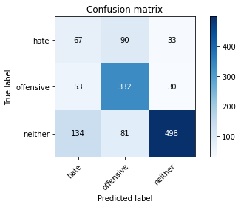

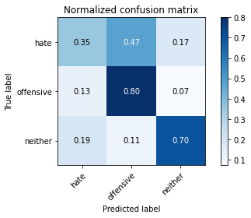

precision recall f1-score support

hate 0.26 0.35 0.30 190

offensive 0.66 0.80 0.72 415

neither 0.89 0.70 0.78 713

accuracy 0.68 1318

macro avg 0.60 0.62 0.60 1318

weighted avg 0.73 0.68 0.69 1318

average eval_loss: 1.0749622515656732, accuracy: 0.6805766312594841

training 6 epoch...

102.03450107574463 seconds used......

6 training finished! average train loss: 0.14149753757032096

total clf loss: 20.934057358652353 total adv loss: 6.0881832121740445

evaluating...

Confusion matrix, without normalization

[[ 54 82 54]

[ 37 330 48]

[ 64 71 578]]

Normalized confusion matrix

[[0.28421053 0.43157895 0.28421053]

[0.08915663 0.79518072 0.11566265]

[0.08976157 0.09957924 0.81065919]]

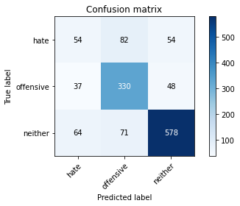

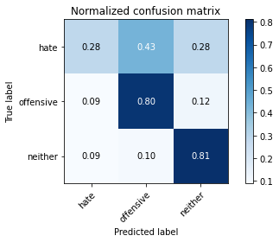

precision recall f1-score support

hate 0.35 0.28 0.31 190

offensive 0.68 0.80 0.73 415

neither 0.85 0.81 0.83 713

accuracy 0.73 1318

macro avg 0.63 0.63 0.63 1318

weighted avg 0.73 0.73 0.73 1318

average eval_loss: 1.0668712005470737, accuracy: 0.7298937784522003

training 7 epoch...

102.02812242507935 seconds used......

7 training finished! average train loss: 0.0960911289220636

total clf loss: 13.316146372060757 total adv loss: 4.5845889080704865

evaluating...

Confusion matrix, without normalization

[[ 51 74 65]

[ 28 310 77]

[ 41 42 630]]

Normalized confusion matrix

[[0.26842105 0.38947368 0.34210526]

[0.06746988 0.74698795 0.18554217]

[0.05750351 0.05890603 0.88359046]]

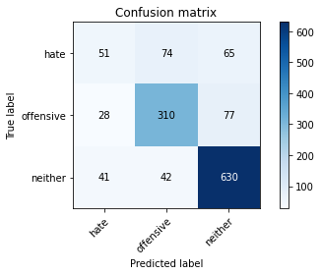

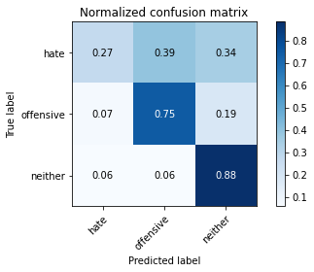

precision recall f1-score support

hate 0.42 0.27 0.33 190

offensive 0.73 0.75 0.74 415

neither 0.82 0.88 0.85 713

accuracy 0.75 1318

macro avg 0.66 0.63 0.64 1318

weighted avg 0.73 0.75 0.74 1318

average eval_loss: 1.1948293795188267, accuracy: 0.7518968133535661

training 8 epoch...

101.99050545692444 seconds used......

8 training finished! average train loss: 0.07921538204820348

total clf loss: 9.972221485804766 total adv loss: 4.282088897360154

evaluating...

Confusion matrix, without normalization

[[ 77 67 46]

[ 59 307 49]

[104 45 564]]

Normalized confusion matrix

[[0.40526316 0.35263158 0.24210526]

[0.14216867 0.73975904 0.11807229]

[0.14586255 0.0631136 0.79102384]]

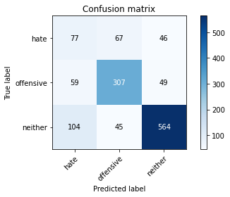

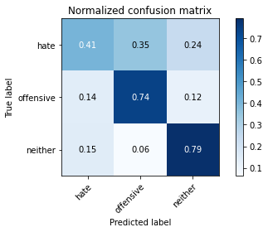

precision recall f1-score support

hate 0.32 0.41 0.36 190

offensive 0.73 0.74 0.74 415

neither 0.86 0.79 0.82 713

accuracy 0.72 1318

macro avg 0.64 0.65 0.64 1318

weighted avg 0.74 0.72 0.73 1318

average eval_loss: 1.2631679353388874, accuracy: 0.7192716236722306

training 9 epoch...

102.0461790561676 seconds used......

9 training finished! average train loss: 0.08237076533210073

total clf loss: 8.007481377688237 total adv loss: 5.633638861232612

evaluating...

Confusion matrix, without normalization

[[ 58 84 48]

[ 36 332 47]

[ 86 77 550]]

Normalized confusion matrix

[[0.30526316 0.44210526 0.25263158]

[0.08674699 0.8 0.11325301]

[0.12061711 0.10799439 0.7713885 ]]

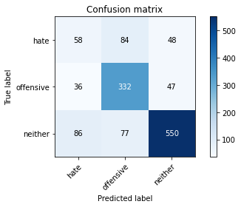

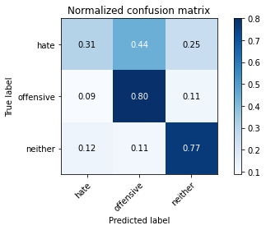

precision recall f1-score support

hate 0.32 0.31 0.31 190

offensive 0.67 0.80 0.73 415

neither 0.85 0.77 0.81 713

accuracy 0.71 1318

macro avg 0.62 0.63 0.62 1318

weighted avg 0.72 0.71 0.71 1318

average eval_loss: 1.357655816005938, accuracy: 0.7132018209408194

training 10 epoch...

102.05576634407043 seconds used......

10 training finished! average train loss: 0.07035122007060932

total clf loss: 7.46477503789356 total adv loss: 4.4987052703891095

evaluating...

Confusion matrix, without normalization

[[ 30 92 68]

[ 23 329 63]

[ 41 84 588]]

Normalized confusion matrix

[[0.15789474 0.48421053 0.35789474]

[0.05542169 0.79277108 0.15180723]

[0.05750351 0.11781206 0.82468443]]

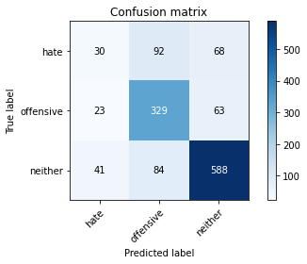

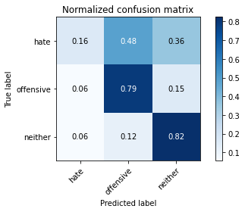

precision recall f1-score support

hate 0.32 0.16 0.21 190

offensive 0.65 0.79 0.72 415

neither 0.82 0.82 0.82 713

accuracy 0.72 1318

macro avg 0.60 0.59 0.58 1318

weighted avg 0.69 0.72 0.70 1318

average eval_loss: 1.3910342283321149, accuracy: 0.7185128983308042

2 run......

training 1 epoch...

102.04936265945435 seconds used......

1 training finished! average train loss: 1.4796595415498457

total clf loss: 154.47973619401455 total adv loss: 95.88029830902815

evaluating...

Confusion matrix, without normalization

[[ 6 110 74]

[ 4 351 60]

[ 7 69 637]]

Normalized confusion matrix

[[0.03157895 0.57894737 0.38947368]

[0.00963855 0.84578313 0.14457831]

[0.00981767 0.09677419 0.89340813]]

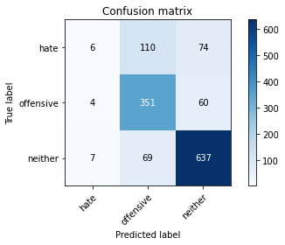

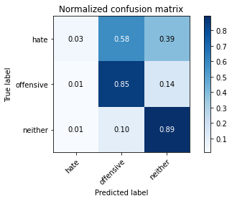

precision recall f1-score support

hate 0.35 0.03 0.06 190

offensive 0.66 0.85 0.74 415

neither 0.83 0.89 0.86 713

accuracy 0.75 1318

macro avg 0.61 0.59 0.55 1318

weighted avg 0.71 0.75 0.71 1318

average eval_loss: 0.6178498728708788, accuracy: 0.7541729893778453

training 2 epoch...

102.05790448188782 seconds used......

2 training finished! average train loss: 1.042422440699023

total clf loss: 111.06524205952883 total adv loss: 66.43080432713032

evaluating...

Confusion matrix, without normalization

[[ 39 87 64]

[ 22 339 54]

[ 37 57 619]]

Normalized confusion matrix

[[0.20526316 0.45789474 0.33684211]

[0.05301205 0.81686747 0.13012048]

[0.05189341 0.0799439 0.86816269]]

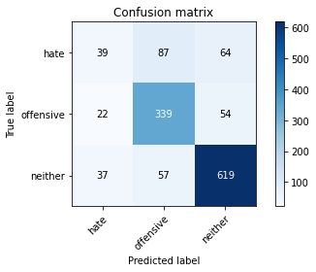

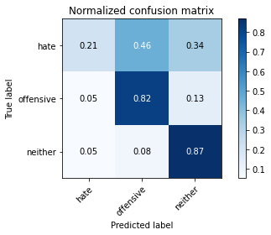

precision recall f1-score support

hate 0.40 0.21 0.27 190

offensive 0.70 0.82 0.76 415

neither 0.84 0.87 0.85 713

accuracy 0.76 1318

macro avg 0.65 0.63 0.63 1318

weighted avg 0.73 0.76 0.74 1318

average eval_loss: 0.6096244982697747, accuracy: 0.7564491654021245

training 3 epoch...

102.07368421554565 seconds used......

3 training finished! average train loss: 0.6968571589224868

total clf loss: 77.96920498460531 total adv loss: 42.547684946563095

evaluating...

Confusion matrix, without normalization

[[ 29 102 59]

[ 21 356 38]

[ 37 96 580]]

Normalized confusion matrix

[[0.15263158 0.53684211 0.31052632]

[0.05060241 0.85783133 0.09156627]

[0.05189341 0.13464236 0.81346424]]

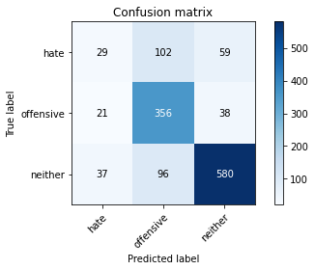

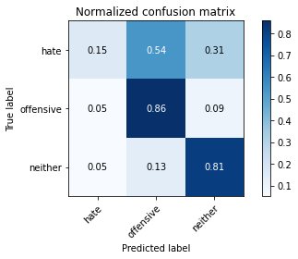

precision recall f1-score support

hate 0.33 0.15 0.21 190

offensive 0.64 0.86 0.73 415

neither 0.86 0.81 0.83 713

accuracy 0.73 1318

macro avg 0.61 0.61 0.59 1318

weighted avg 0.71 0.73 0.71 1318

average eval_loss: 0.7763175210266402, accuracy: 0.7321699544764795

training 4 epoch...

102.1069278717041 seconds used......

4 training finished! average train loss: 0.4028590755680433

total clf loss: 51.65440012514591 total adv loss: 21.30731175316032

evaluating...

Confusion matrix, without normalization

[[ 73 72 45]

[ 46 324 45]

[107 42 564]]

Normalized confusion matrix

[[0.38421053 0.37894737 0.23684211]

[0.11084337 0.78072289 0.10843373]

[0.15007013 0.05890603 0.79102384]]

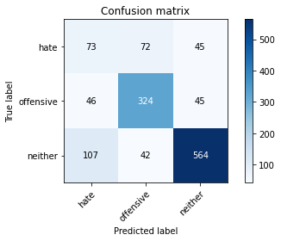

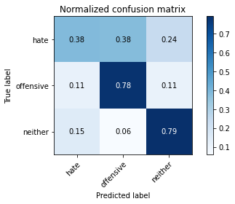

precision recall f1-score support

hate 0.32 0.38 0.35 190

offensive 0.74 0.78 0.76 415

neither 0.86 0.79 0.83 713

accuracy 0.73 1318

macro avg 0.64 0.65 0.65 1318

weighted avg 0.75 0.73 0.74 1318

average eval_loss: 0.8412569111043756, accuracy: 0.7291350531107739

training 5 epoch...

102.06179141998291 seconds used......

5 training finished! average train loss: 0.2274442533464927

total clf loss: 32.01274071354419 total adv loss: 10.604607387096621

evaluating...

Confusion matrix, without normalization

[[ 51 87 52]

[ 35 338 42]

[ 78 78 557]]

Normalized confusion matrix

[[0.26842105 0.45789474 0.27368421]

[0.08433735 0.81445783 0.10120482]

[0.10939691 0.10939691 0.78120617]]

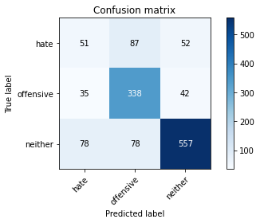

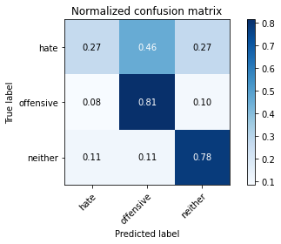

precision recall f1-score support

hate 0.31 0.27 0.29 190

offensive 0.67 0.81 0.74 415

neither 0.86 0.78 0.82 713

accuracy 0.72 1318

macro avg 0.61 0.62 0.61 1318

weighted avg 0.72 0.72 0.72 1318

average eval_loss: 0.9790690656412732, accuracy: 0.7177541729893778

training 6 epoch...

102.0989899635315 seconds used......

6 training finished! average train loss: 0.1335401084496934

total clf loss: 20.506027293857187 total adv loss: 5.371179037138063

evaluating...

Confusion matrix, without normalization

[[ 43 95 52]

[ 30 353 32]

[ 77 102 534]]

Normalized confusion matrix

[[0.22631579 0.5 0.27368421]

[0.07228916 0.85060241 0.07710843]

[0.10799439 0.1430575 0.74894811]]

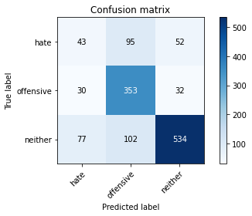

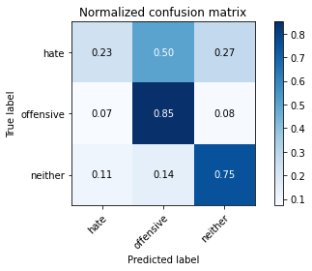

precision recall f1-score support

hate 0.29 0.23 0.25 190

offensive 0.64 0.85 0.73 415

neither 0.86 0.75 0.80 713

accuracy 0.71 1318

macro avg 0.60 0.61 0.60 1318

weighted avg 0.71 0.71 0.70 1318

average eval_loss: 1.1747818051865606, accuracy: 0.7056145675265554

training 7 epoch...

102.15280365943909 seconds used......

7 training finished! average train loss: 0.10343818840646368

total clf loss: 13.873380638193339 total adv loss: 5.1655778040458245

evaluating...

Confusion matrix, without normalization

[[ 60 65 65]

[ 69 299 47]

[104 46 563]]

Normalized confusion matrix

[[0.31578947 0.34210526 0.34210526]

[0.16626506 0.72048193 0.11325301]

[0.14586255 0.06451613 0.78962132]]

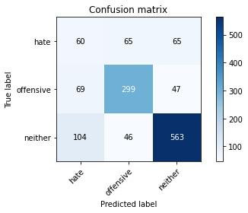

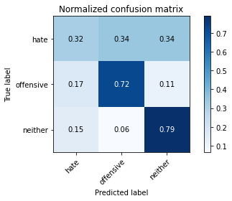

precision recall f1-score support

hate 0.26 0.32 0.28 190

offensive 0.73 0.72 0.72 415

neither 0.83 0.79 0.81 713

accuracy 0.70 1318

macro avg 0.61 0.61 0.61 1318

weighted avg 0.72 0.70 0.71 1318

average eval_loss: 1.1385689811273054, accuracy: 0.6995447647951442

training 8 epoch...

102.10966491699219 seconds used......

8 training finished! average train loss: 0.09306430334173557

total clf loss: 10.943425987963565 total adv loss: 5.416810482369328

evaluating...

Confusion matrix, without normalization

[[ 48 78 64]

[ 39 327 49]

[ 84 60 569]]

Normalized confusion matrix

[[0.25263158 0.41052632 0.33684211]

[0.0939759 0.78795181 0.11807229]

[0.11781206 0.08415147 0.79803647]]

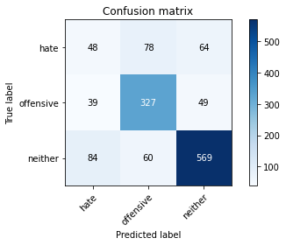

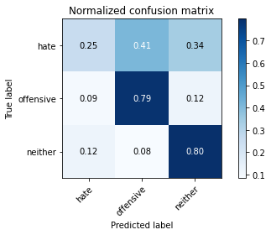

precision recall f1-score support

hate 0.28 0.25 0.27 190

offensive 0.70 0.79 0.74 415

neither 0.83 0.80 0.82 713

accuracy 0.72 1318

macro avg 0.61 0.61 0.61 1318

weighted avg 0.71 0.72 0.71 1318

average eval_loss: 1.290250431859132, accuracy: 0.716236722306525

training 9 epoch...

102.14323616027832 seconds used......

9 training finished! average train loss: 0.060740560508615725

total clf loss: 7.52098354982445 total adv loss: 3.3461538028509494

evaluating...

Confusion matrix, without normalization

[[ 31 101 58]

[ 24 338 53]

[ 59 79 575]]

Normalized confusion matrix

[[0.16315789 0.53157895 0.30526316]

[0.05783133 0.81445783 0.12771084]

[0.08274895 0.11079944 0.80645161]]

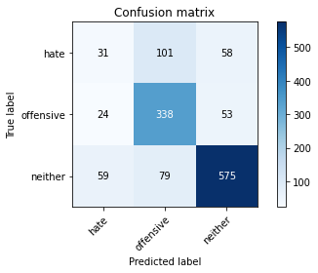

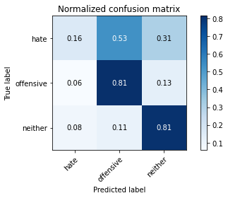

precision recall f1-score support

hate 0.27 0.16 0.20 190

offensive 0.65 0.81 0.72 415

neither 0.84 0.81 0.82 713

accuracy 0.72 1318

macro avg 0.59 0.59 0.58 1318

weighted avg 0.70 0.72 0.70 1318

average eval_loss: 1.2761958774292108, accuracy: 0.716236722306525

training 10 epoch...

102.19052052497864 seconds used......

10 training finished! average train loss: 0.06596712984441198

total clf loss: 7.524403412215179 total adv loss: 3.955952456423688

evaluating...

Confusion matrix, without normalization

[[ 56 72 62]

[ 52 310 53]

[ 85 59 569]]

Normalized confusion matrix

[[0.29473684 0.37894737 0.32631579]

[0.1253012 0.74698795 0.12771084]

[0.11921459 0.08274895 0.79803647]]

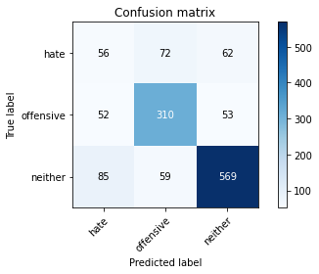

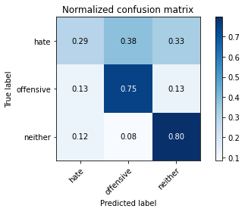

precision recall f1-score support

hate 0.29 0.29 0.29 190

offensive 0.70 0.75 0.72 415

neither 0.83 0.80 0.81 713

accuracy 0.71 1318

macro avg 0.61 0.61 0.61 1318

weighted avg 0.71 0.71 0.71 1318

average eval_loss: 1.3076479532050365, accuracy: 0.7094081942336874

3 run......

training 1 epoch...

102.13934206962585 seconds used......

1 training finished! average train loss: 1.4824931947594016

total clf loss: 153.7951652109623 total adv loss: 96.55412145704031

evaluating...

Confusion matrix, without normalization

[[ 24 106 60]

[ 24 359 32]

[ 28 94 591]]

Normalized confusion matrix

[[0.12631579 0.55789474 0.31578947]

[0.05783133 0.86506024 0.07710843]

[0.03927069 0.13183731 0.82889201]]

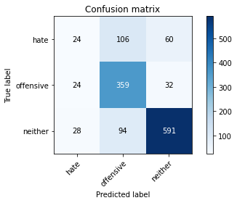

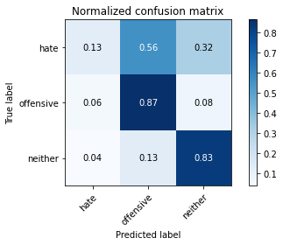

precision recall f1-score support

hate 0.32 0.13 0.18 190

offensive 0.64 0.87 0.74 415

neither 0.87 0.83 0.85 713

accuracy 0.74 1318

macro avg 0.61 0.61 0.59 1318

weighted avg 0.72 0.74 0.72 1318

average eval_loss: 0.6382776029182203, accuracy: 0.7389984825493171

training 2 epoch...

101.96057677268982 seconds used......

2 training finished! average train loss: 1.0279114954491966

total clf loss: 109.74481882154942 total adv loss: 65.39323554933071

evaluating...

Confusion matrix, without normalization

[[ 26 96 68]

[ 17 347 51]

[ 24 64 625]]

Normalized confusion matrix

[[0.13684211 0.50526316 0.35789474]

[0.04096386 0.83614458 0.12289157]

[0.03366059 0.08976157 0.87657784]]

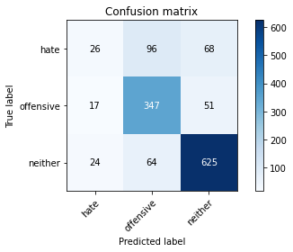

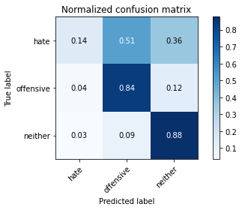

precision recall f1-score support

hate 0.39 0.14 0.20 190

offensive 0.68 0.84 0.75 415

neither 0.84 0.88 0.86 713

accuracy 0.76 1318

macro avg 0.64 0.62 0.60 1318

weighted avg 0.73 0.76 0.73 1318

average eval_loss: 0.6057760367790858, accuracy: 0.7572078907435509

training 3 epoch...

102.06322765350342 seconds used......

3 training finished! average train loss: 0.7050171838675299

total clf loss: 80.02738858014345 total adv loss: 42.47331609111279

evaluating...

Confusion matrix, without normalization

[[ 64 55 71]

[ 36 311 68]

[ 44 40 629]]

Normalized confusion matrix

[[0.33684211 0.28947368 0.37368421]

[0.08674699 0.74939759 0.16385542]

[0.06171108 0.05610098 0.88218794]]

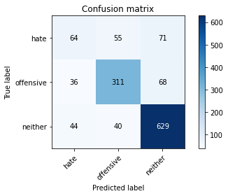

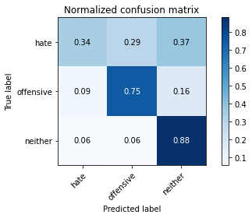

precision recall f1-score support

hate 0.44 0.34 0.38 190

offensive 0.77 0.75 0.76 415

neither 0.82 0.88 0.85 713

accuracy 0.76 1318

macro avg 0.68 0.66 0.66 1318

weighted avg 0.75 0.76 0.75 1318

average eval_loss: 0.6493351766557405, accuracy: 0.7617602427921093

training 4 epoch...

101.96901059150696 seconds used......

4 training finished! average train loss: 0.37631837682973623

total clf loss: 49.509655363857746 total adv loss: 19.274422246031463

evaluating...

Confusion matrix, without normalization

[[ 66 83 41]

[ 42 331 42]

[ 97 67 549]]

Normalized confusion matrix

[[0.34736842 0.43684211 0.21578947]

[0.10120482 0.79759036 0.10120482]

[0.13604488 0.09396914 0.76998597]]

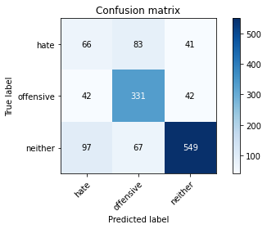

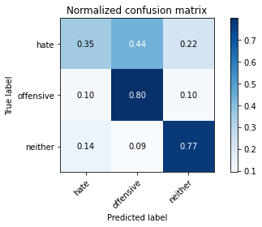

precision recall f1-score support

hate 0.32 0.35 0.33 190

offensive 0.69 0.80 0.74 415

neither 0.87 0.77 0.82 713

accuracy 0.72 1318

macro avg 0.63 0.64 0.63 1318

weighted avg 0.73 0.72 0.72 1318

average eval_loss: 0.8735641805511533, accuracy: 0.7177541729893778

training 5 epoch...

102.0084810256958 seconds used......

5 training finished! average train loss: 0.22624794668398607

total clf loss: 32.727499516215175 total adv loss: 10.107259999014786

evaluating...

Confusion matrix, without normalization

[[ 79 69 42]

[ 55 322 38]

[108 46 559]]

Normalized confusion matrix

[[0.41578947 0.36315789 0.22105263]

[0.13253012 0.77590361 0.09156627]

[0.15147265 0.06451613 0.78401122]]

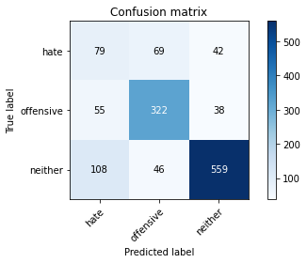

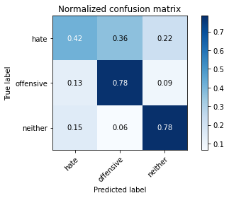

precision recall f1-score support

hate 0.33 0.42 0.37 190

offensive 0.74 0.78 0.76 415

neither 0.87 0.78 0.83 713

accuracy 0.73 1318

macro avg 0.65 0.66 0.65 1318

weighted avg 0.75 0.73 0.74 1318

average eval_loss: 0.9365269139860616, accuracy: 0.7283763277693475

training 6 epoch...

101.972327709198 seconds used......

6 training finished! average train loss: 0.17000724568875492

total clf loss: 24.954441477078944 total adv loss: 7.41362703658524

evaluating...

Confusion matrix, without normalization

[[ 60 78 52]

[ 48 317 50]

[ 85 50 578]]

Normalized confusion matrix

[[0.31578947 0.41052632 0.27368421]

[0.11566265 0.76385542 0.12048193]

[0.11921459 0.07012623 0.81065919]]

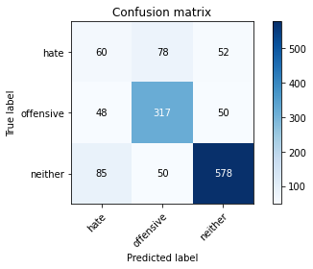

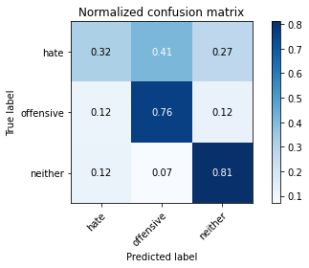

precision recall f1-score support

hate 0.31 0.32 0.31 190

offensive 0.71 0.76 0.74 415

neither 0.85 0.81 0.83 713

accuracy 0.72 1318

macro avg 0.62 0.63 0.63 1318

weighted avg 0.73 0.72 0.73 1318

average eval_loss: 1.0213231846238628, accuracy: 0.7245827010622155

training 7 epoch...

101.9783124923706 seconds used......

7 training finished! average train loss: 0.12068279364552253

total clf loss: 15.981971822213382 total adv loss: 6.1289008772009765

evaluating...

Confusion matrix, without normalization

[[ 53 91 46]

[ 43 335 37]

[102 59 552]]

Normalized confusion matrix

[[0.27894737 0.47894737 0.24210526]

[0.10361446 0.80722892 0.08915663]

[0.1430575 0.08274895 0.77419355]]

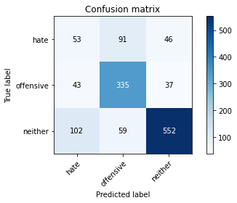

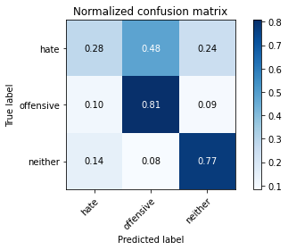

precision recall f1-score support

hate 0.27 0.28 0.27 190

offensive 0.69 0.81 0.74 415

neither 0.87 0.77 0.82 713

accuracy 0.71 1318

macro avg 0.61 0.62 0.61 1318

weighted avg 0.73 0.71 0.72 1318

average eval_loss: 1.147347368074186, accuracy: 0.7132018209408194

training 8 epoch...

102.17141556739807 seconds used......

8 training finished! average train loss: 0.12528674006581497

total clf loss: 14.605050558806397 total adv loss: 7.356023331009055

evaluating...

Confusion matrix, without normalization

[[ 67 69 54]

[ 48 324 43]

[ 94 47 572]]

Normalized confusion matrix

[[0.35263158 0.36315789 0.28421053]

[0.11566265 0.78072289 0.10361446]

[0.13183731 0.06591865 0.80224404]]

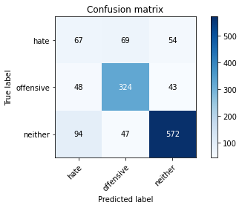

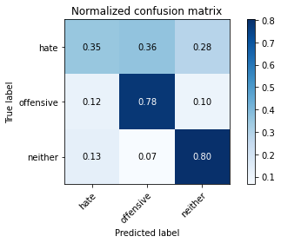

precision recall f1-score support

hate 0.32 0.35 0.34 190

offensive 0.74 0.78 0.76 415

neither 0.86 0.80 0.83 713

accuracy 0.73 1318

macro avg 0.64 0.65 0.64 1318

weighted avg 0.74 0.73 0.73 1318

average eval_loss: 1.1349146257747302, accuracy: 0.7306525037936267

training 9 epoch...

102.1490228176117 seconds used......

9 training finished! average train loss: 0.05848378195172638

total clf loss: 7.392505467112642 total adv loss: 3.1463497679160355

evaluating...

Confusion matrix, without normalization

[[ 48 83 59]

[ 34 321 60]

[ 79 53 581]]

Normalized confusion matrix

[[0.25263158 0.43684211 0.31052632]

[0.08192771 0.77349398 0.14457831]

[0.11079944 0.0743338 0.81486676]]

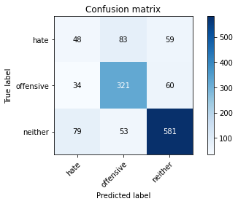

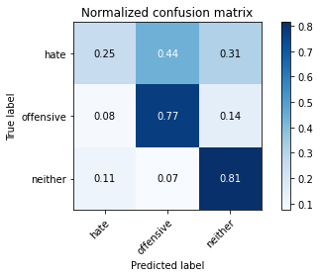

precision recall f1-score support

hate 0.30 0.25 0.27 190

offensive 0.70 0.77 0.74 415

neither 0.83 0.81 0.82 713

accuracy 0.72 1318

macro avg 0.61 0.61 0.61 1318

weighted avg 0.71 0.72 0.72 1318

average eval_loss: 1.23244756685965, accuracy: 0.7207890743550834

training 10 epoch...

102.04854536056519 seconds used......

10 training finished! average train loss: 0.054767049881868445

total clf loss: 6.678732981032226 total adv loss: 3.068378316318558

evaluating...

Confusion matrix, without normalization

[[ 74 77 39]

[ 57 326 32]

[127 61 525]]

Normalized confusion matrix

[[0.38947368 0.40526316 0.20526316]

[0.1373494 0.78554217 0.07710843]

[0.17812062 0.085554 0.73632539]]

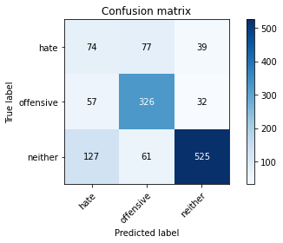

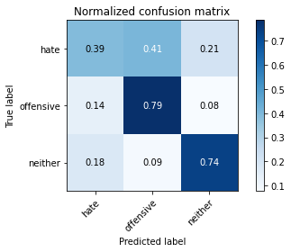

precision recall f1-score support

hate 0.29 0.39 0.33 190

offensive 0.70 0.79 0.74 415

neither 0.88 0.74 0.80 713

accuracy 0.70 1318

macro avg 0.62 0.64 0.62 1318

weighted avg 0.74 0.70 0.72 1318

average eval_loss: 1.2888108907323894, accuracy: 0.7018209408194234

4 run......

training 1 epoch...

102.18049716949463 seconds used......

1 training finished! average train loss: 1.469163756339978

total clf loss: 152.07560743391514 total adv loss: 95.85435570031404

evaluating...

Confusion matrix, without normalization

[[ 73 60 57]

[ 39 319 57]

[ 64 37 612]]

Normalized confusion matrix

[[0.38421053 0.31578947 0.3 ]

[0.0939759 0.7686747 0.1373494 ]

[0.08976157 0.05189341 0.85834502]]

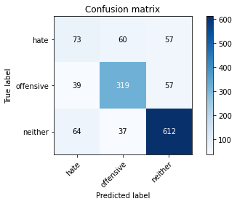

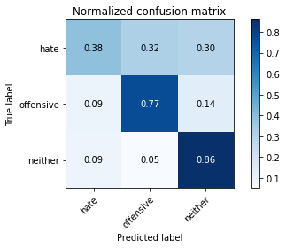

precision recall f1-score support

hate 0.41 0.38 0.40 190

offensive 0.77 0.77 0.77 415

neither 0.84 0.86 0.85 713

accuracy 0.76 1318

macro avg 0.67 0.67 0.67 1318

weighted avg 0.76 0.76 0.76 1318

average eval_loss: 0.5968001259095741, accuracy: 0.7617602427921093

training 2 epoch...

102.28808784484863 seconds used......

2 training finished! average train loss: 1.0403453430686243

total clf loss: 109.33296134322882 total adv loss: 67.05392449721694

evaluating...

Confusion matrix, without normalization

[[ 39 90 61]

[ 22 330 63]

[ 43 54 616]]

Normalized confusion matrix

[[0.20526316 0.47368421 0.32105263]

[0.05301205 0.79518072 0.15180723]

[0.06030856 0.07573633 0.86395512]]

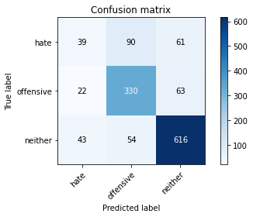

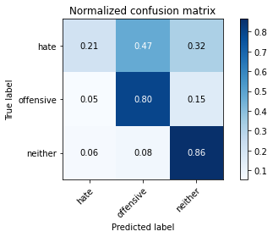

precision recall f1-score support

hate 0.38 0.21 0.27 190

offensive 0.70 0.80 0.74 415

neither 0.83 0.86 0.85 713

accuracy 0.75 1318

macro avg 0.63 0.62 0.62 1318

weighted avg 0.72 0.75 0.73 1318

average eval_loss: 0.6172438828331052, accuracy: 0.7473444613050075

training 3 epoch...

102.28721022605896 seconds used......

3 training finished! average train loss: 0.6870117284930669

total clf loss: 77.77908276766539 total adv loss: 41.490831079892814

evaluating...

Confusion matrix, without normalization

[[ 69 57 64]

[ 57 282 76]

[ 73 20 620]]

Normalized confusion matrix

[[0.36315789 0.3 0.33684211]

[0.1373494 0.67951807 0.18313253]

[0.10238429 0.02805049 0.86956522]]

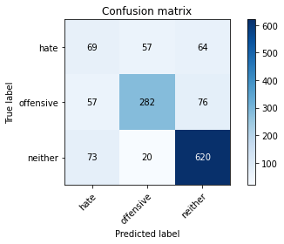

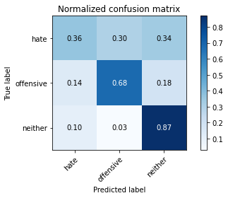

precision recall f1-score support

hate 0.35 0.36 0.35 190

offensive 0.79 0.68 0.73 415

neither 0.82 0.87 0.84 713

accuracy 0.74 1318

macro avg 0.65 0.64 0.64 1318

weighted avg 0.74 0.74 0.74 1318

average eval_loss: 0.7010357167684671, accuracy: 0.7367223065250379

training 4 epoch...

102.26289987564087 seconds used......

4 training finished! average train loss: 0.3922053367122371

total clf loss: 49.2838320992887 total adv loss: 21.246108318911865

evaluating...

Confusion matrix, without normalization

[[ 45 95 50]

[ 26 348 41]

[ 43 94 576]]

Normalized confusion matrix

[[0.23684211 0.5 0.26315789]

[0.0626506 0.83855422 0.09879518]

[0.06030856 0.13183731 0.80785414]]

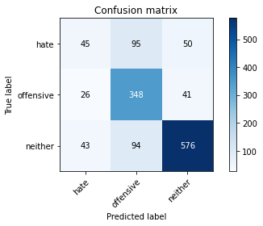

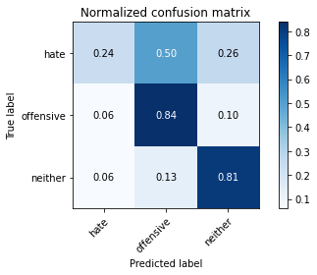

precision recall f1-score support

hate 0.39 0.24 0.30 190

offensive 0.65 0.84 0.73 415

neither 0.86 0.81 0.83 713

accuracy 0.74 1318

macro avg 0.64 0.63 0.62 1318

weighted avg 0.73 0.74 0.72 1318

average eval_loss: 0.9035038677128878, accuracy: 0.7352048558421851

training 5 epoch...

102.26939034461975 seconds used......

5 training finished! average train loss: 0.23643019079811808

total clf loss: 31.798749580979347 total adv loss: 11.762957625614945

evaluating...

Confusion matrix, without normalization

[[ 87 37 66]

[ 89 245 81]

[ 81 15 617]]

Normalized confusion matrix

[[0.45789474 0.19473684 0.34736842]

[0.21445783 0.59036145 0.19518072]

[0.11360449 0.02103787 0.86535764]]

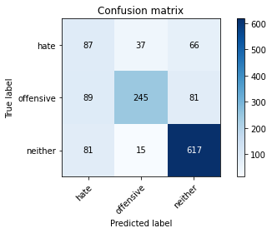

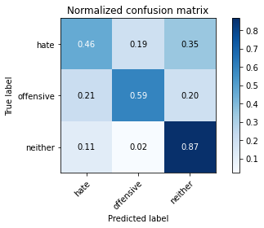

precision recall f1-score support

hate 0.34 0.46 0.39 190

offensive 0.82 0.59 0.69 415

neither 0.81 0.87 0.84 713

accuracy 0.72 1318

macro avg 0.66 0.64 0.64 1318

weighted avg 0.75 0.72 0.72 1318

average eval_loss: 0.892503663445964, accuracy: 0.720030349013657

training 6 epoch...

102.30424165725708 seconds used......

6 training finished! average train loss: 0.15037583717160946

total clf loss: 20.11510315630585 total adv loss: 7.53642138289797

evaluating...

Confusion matrix, without normalization

[[ 66 78 46]

[ 40 329 46]

[ 91 67 555]]

Normalized confusion matrix

[[0.34736842 0.41052632 0.24210526]

[0.09638554 0.79277108 0.11084337]

[0.12762973 0.09396914 0.77840112]]

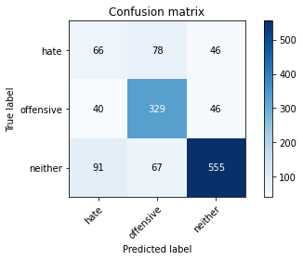

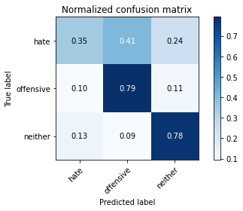

precision recall f1-score support

hate 0.34 0.35 0.34 190

offensive 0.69 0.79 0.74 415

neither 0.86 0.78 0.82 713

accuracy 0.72 1318

macro avg 0.63 0.64 0.63 1318

weighted avg 0.73 0.72 0.72 1318

average eval_loss: 0.9977796028057734, accuracy: 0.7207890743550834

training 7 epoch...

102.29475617408752 seconds used......

7 training finished! average train loss: 0.09467150553022154

total clf loss: 12.932027434464544 total adv loss: 4.610552373728751

evaluating...

Confusion matrix, without normalization

[[ 48 95 47]

[ 35 332 48]

[100 58 555]]

Normalized confusion matrix

[[0.25263158 0.5 0.24736842]

[0.08433735 0.8 0.11566265]

[0.14025245 0.08134642 0.77840112]]

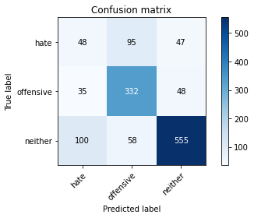

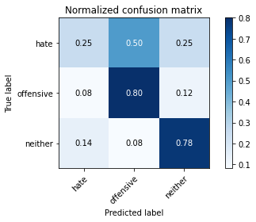

precision recall f1-score support

hate 0.26 0.25 0.26 190

offensive 0.68 0.80 0.74 415

neither 0.85 0.78 0.81 713

accuracy 0.71 1318

macro avg 0.60 0.61 0.60 1318

weighted avg 0.72 0.71 0.71 1318

average eval_loss: 1.2003831858887817, accuracy: 0.7094081942336874

training 8 epoch...

102.32438111305237 seconds used......

8 training finished! average train loss: 0.08005323298932172

total clf loss: 9.623090265435167 total adv loss: 4.554683164424205

evaluating...

Confusion matrix, without normalization

[[ 76 78 36]

[ 53 323 39]

[135 58 520]]

Normalized confusion matrix

[[0.4 0.41052632 0.18947368]

[0.12771084 0.77831325 0.0939759 ]

[0.18934081 0.08134642 0.72931276]]

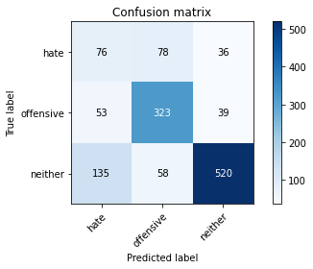

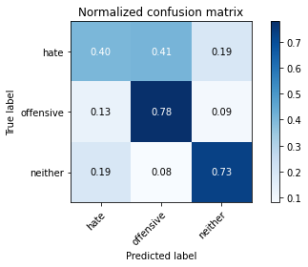

precision recall f1-score support

hate 0.29 0.40 0.33 190

offensive 0.70 0.78 0.74 415

neither 0.87 0.73 0.80 713

accuracy 0.70 1318

macro avg 0.62 0.64 0.62 1318

weighted avg 0.74 0.70 0.71 1318

average eval_loss: 1.2646513549667415, accuracy: 0.697268588770865

training 9 epoch...

102.31820154190063 seconds used......

9 training finished! average train loss: 0.07264733345806997

total clf loss: 7.594677891465835 total adv loss: 4.70239908781241

evaluating...

Confusion matrix, without normalization

[[ 67 84 39]

[ 43 336 36]

[117 72 524]]

Normalized confusion matrix

[[0.35263158 0.44210526 0.20526316]

[0.10361446 0.80963855 0.08674699]

[0.16409537 0.10098177 0.73492286]]

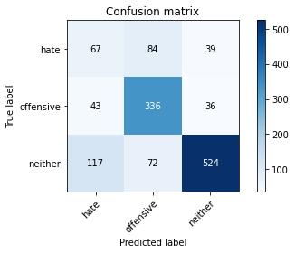

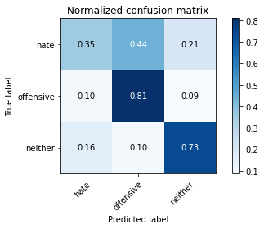

precision recall f1-score support

hate 0.30 0.35 0.32 190

offensive 0.68 0.81 0.74 415

neither 0.87 0.73 0.80 713

accuracy 0.70 1318

macro avg 0.62 0.63 0.62 1318

weighted avg 0.73 0.70 0.71 1318

average eval_loss: 1.321358369606914, accuracy: 0.7033383915022762

training 10 epoch...

102.40893077850342 seconds used......

10 training finished! average train loss: 0.04923938023290621

total clf loss: 6.011850173847051 total adv loss: 2.755082382758701

evaluating...

Confusion matrix, without normalization

[[ 30 88 72]

[ 23 327 65]

[ 48 54 611]]

Normalized confusion matrix

[[0.15789474 0.46315789 0.37894737]

[0.05542169 0.78795181 0.15662651]

[0.06732118 0.07573633 0.8569425 ]]

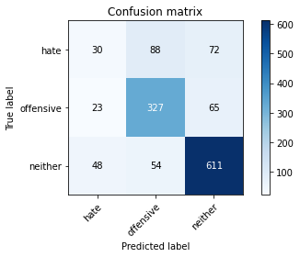

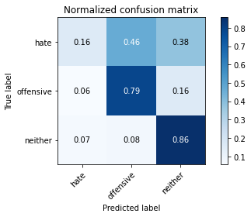

precision recall f1-score support

hate 0.30 0.16 0.21 190

offensive 0.70 0.79 0.74 415

neither 0.82 0.86 0.84 713

accuracy 0.73 1318

macro avg 0.60 0.60 0.59 1318

weighted avg 0.70 0.73 0.72 1318

average eval_loss: 1.366505101774678, accuracy: 0.7344461305007587

5 run......

training 1 epoch...

102.58475089073181 seconds used......

1 training finished! average train loss: 1.4833721245965388

total clf loss: 154.7558030486107 total adv loss: 96.1766370087862

evaluating...

Confusion matrix, without normalization

[[ 22 93 75]

[ 13 337 65]

[ 15 51 647]]

Normalized confusion matrix

[[0.11578947 0.48947368 0.39473684]

[0.0313253 0.81204819 0.15662651]

[0.02103787 0.07152875 0.90743338]]

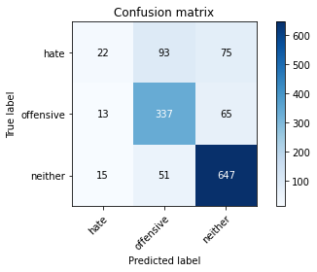

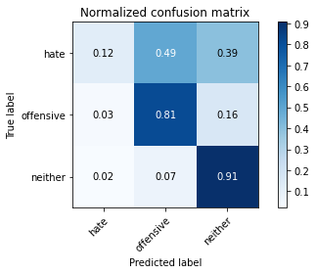

precision recall f1-score support

hate 0.44 0.12 0.18 190

offensive 0.70 0.81 0.75 415

neither 0.82 0.91 0.86 713

accuracy 0.76 1318

macro avg 0.65 0.61 0.60 1318

weighted avg 0.73 0.76 0.73 1318

average eval_loss: 0.5949592667095589, accuracy: 0.7632776934749621

training 2 epoch...

101.64882683753967 seconds used......

2 training finished! average train loss: 1.0408140764786646

total clf loss: 110.048584446311 total adv loss: 66.75095477700233

evaluating...

Confusion matrix, without normalization

[[ 50 65 75]

[ 26 326 63]

[ 31 50 632]]

Normalized confusion matrix

[[0.26315789 0.34210526 0.39473684]

[0.0626506 0.78554217 0.15180723]

[0.04347826 0.07012623 0.88639551]]

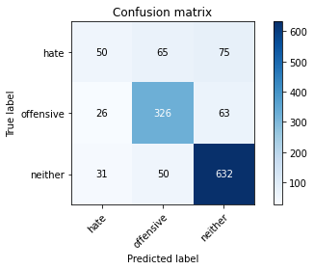

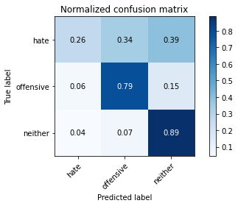

precision recall f1-score support

hate 0.47 0.26 0.34 190

offensive 0.74 0.79 0.76 415

neither 0.82 0.89 0.85 713

accuracy 0.76 1318

macro avg 0.68 0.65 0.65 1318

weighted avg 0.74 0.76 0.75 1318

average eval_loss: 0.5956795901963206, accuracy: 0.7647951441578149

training 3 epoch...

101.70571660995483 seconds used......

3 training finished! average train loss: 0.7036111594902145

total clf loss: 79.97746954113245 total adv loss: 42.33377124462277

evaluating...

Confusion matrix, without normalization

[[ 40 89 61]

[ 28 335 52]

[ 35 67 611]]

Normalized confusion matrix

[[0.21052632 0.46842105 0.32105263]

[0.06746988 0.80722892 0.1253012 ]

[0.04908836 0.09396914 0.8569425 ]]

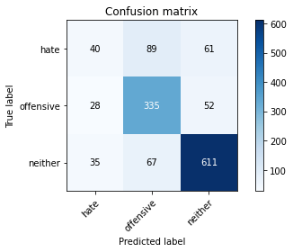

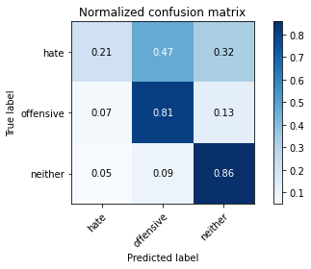

precision recall f1-score support

hate 0.39 0.21 0.27 190

offensive 0.68 0.81 0.74 415

neither 0.84 0.86 0.85 713

accuracy 0.75 1318

macro avg 0.64 0.62 0.62 1318

weighted avg 0.73 0.75 0.73 1318

average eval_loss: 0.6723491007631476, accuracy: 0.7481031866464339

training 4 epoch...

101.64817643165588 seconds used......

4 training finished! average train loss: 0.3816858736447926

total clf loss: 50.78308795019984 total adv loss: 19.265703296579886

evaluating...

Confusion matrix, without normalization

[[ 48 92 50]

[ 34 341 40]

[ 71 86 556]]

Normalized confusion matrix

[[0.25263158 0.48421053 0.26315789]

[0.08192771 0.82168675 0.09638554]

[0.09957924 0.12061711 0.77980365]]

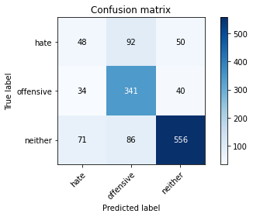

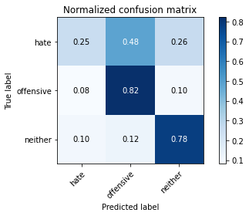

precision recall f1-score support

hate 0.31 0.25 0.28 190

offensive 0.66 0.82 0.73 415

neither 0.86 0.78 0.82 713

accuracy 0.72 1318

macro avg 0.61 0.62 0.61 1318

weighted avg 0.72 0.72 0.71 1318

average eval_loss: 0.9209455048496072, accuracy: 0.7169954476479514

training 5 epoch...

101.68202376365662 seconds used......

5 training finished! average train loss: 0.24132842919988257

total clf loss: 33.57303890492767 total adv loss: 11.448906808247557

evaluating...

Confusion matrix, without normalization

[[ 47 82 61]

[ 36 317 62]

[ 47 45 621]]

Normalized confusion matrix

[[0.24736842 0.43157895 0.32105263]

[0.08674699 0.76385542 0.14939759]

[0.06591865 0.0631136 0.87096774]]

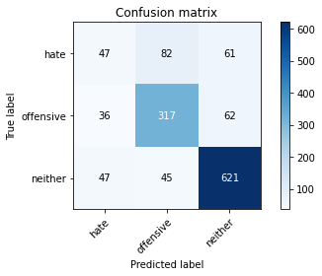

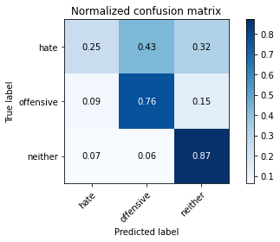

precision recall f1-score support

hate 0.36 0.25 0.29 190

offensive 0.71 0.76 0.74 415

neither 0.83 0.87 0.85 713

accuracy 0.75 1318

macro avg 0.64 0.63 0.63 1318

weighted avg 0.73 0.75 0.74 1318

average eval_loss: 0.93936574549386, accuracy: 0.7473444613050075

training 6 epoch...

101.67638230323792 seconds used......

6 training finished! average train loss: 0.13562622335918534

total clf loss: 20.72328831302002 total adv loss: 5.506623937521454

evaluating...

Confusion matrix, without normalization

[[ 47 93 50]

[ 34 336 45]

[ 55 77 581]]

Normalized confusion matrix

[[0.24736842 0.48947368 0.26315789]

[0.08192771 0.80963855 0.10843373]

[0.07713885 0.10799439 0.81486676]]

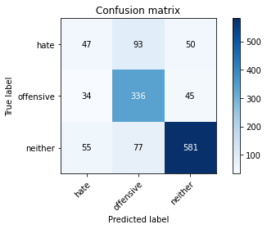

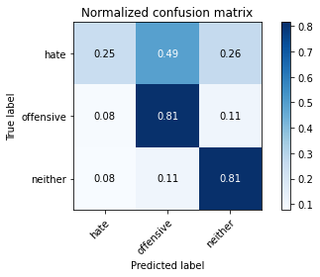

precision recall f1-score support

hate 0.35 0.25 0.29 190

offensive 0.66 0.81 0.73 415

neither 0.86 0.81 0.84 713

accuracy 0.73 1318

macro avg 0.62 0.62 0.62 1318

weighted avg 0.72 0.73 0.72 1318

average eval_loss: 1.0197713221564437, accuracy: 0.7314112291350531

training 7 epoch...

101.71370577812195 seconds used......

7 training finished! average train loss: 0.12692448556916708

total clf loss: 16.516844222322106 total adv loss: 6.591742651271488

evaluating...

Confusion matrix, without normalization

[[ 59 81 50]

[ 48 328 39]

[ 91 58 564]]

Normalized confusion matrix

[[0.31052632 0.42631579 0.26315789]

[0.11566265 0.79036145 0.0939759 ]

[0.12762973 0.08134642 0.79102384]]

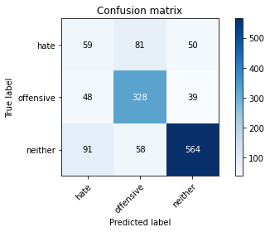

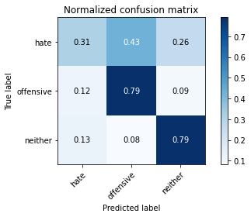

precision recall f1-score support

hate 0.30 0.31 0.30 190

offensive 0.70 0.79 0.74 415

neither 0.86 0.79 0.83 713

accuracy 0.72 1318

macro avg 0.62 0.63 0.62 1318

weighted avg 0.73 0.72 0.72 1318

average eval_loss: 1.017038447838841, accuracy: 0.7215477996965098

training 8 epoch...

101.65232968330383 seconds used......

8 training finished! average train loss: 0.0762309541241226

total clf loss: 10.642529600823764 total adv loss: 3.5977568797511594

evaluating...

Confusion matrix, without normalization

[[ 69 84 37]

[ 49 337 29]

[134 69 510]]

Normalized confusion matrix

[[0.36315789 0.44210526 0.19473684]

[0.11807229 0.81204819 0.06987952]

[0.18793829 0.09677419 0.71528752]]

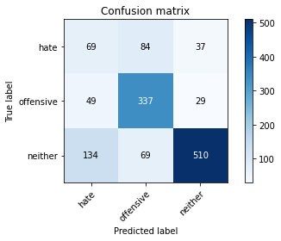

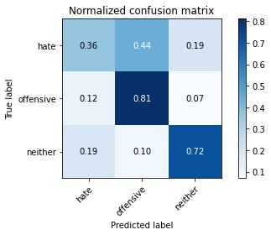

precision recall f1-score support

hate 0.27 0.36 0.31 190

offensive 0.69 0.81 0.74 415

neither 0.89 0.72 0.79 713

accuracy 0.69 1318

macro avg 0.62 0.63 0.62 1318

weighted avg 0.74 0.69 0.71 1318

average eval_loss: 1.304824294465961, accuracy: 0.6949924127465857

training 9 epoch...

101.64358568191528 seconds used......

9 training finished! average train loss: 0.06722457249027987

total clf loss: 7.799434565647971 total adv loss: 3.965557769366086

evaluating...

Confusion matrix, without normalization

[[ 63 80 47]

[ 50 330 35]

[125 67 521]]

Normalized confusion matrix

[[0.33157895 0.42105263 0.24736842]

[0.12048193 0.79518072 0.08433735]

[0.17531557 0.09396914 0.73071529]]

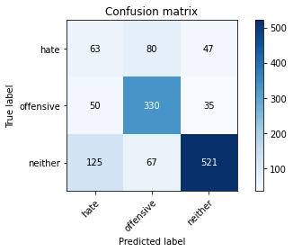

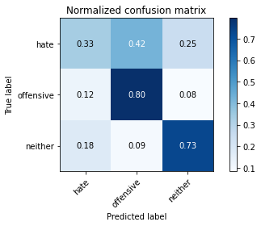

precision recall f1-score support

hate 0.26 0.33 0.29 190

offensive 0.69 0.80 0.74 415

neither 0.86 0.73 0.79 713

accuracy 0.69 1318

macro avg 0.61 0.62 0.61 1318

weighted avg 0.72 0.69 0.70 1318

average eval_loss: 1.3087579900342408, accuracy: 0.6934749620637329

training 10 epoch...

101.7035870552063 seconds used......

10 training finished! average train loss: 0.07352124080502201

total clf loss: 7.93350167524477 total adv loss: 4.635234341183377

evaluating...

Confusion matrix, without normalization

[[ 79 68 43]

[ 57 321 37]

[112 50 551]]

Normalized confusion matrix

[[0.41578947 0.35789474 0.22631579]

[0.1373494 0.77349398 0.08915663]

[0.15708275 0.07012623 0.77279102]]

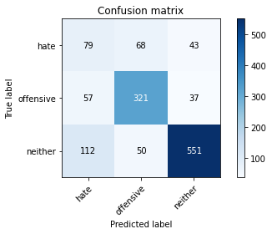

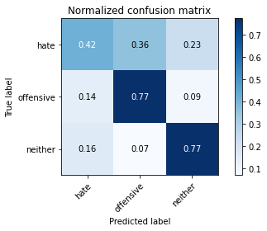

precision recall f1-score support

hate 0.32 0.42 0.36 190

offensive 0.73 0.77 0.75 415

neither 0.87 0.77 0.82 713

accuracy 0.72 1318

macro avg 0.64 0.65 0.64 1318

weighted avg 0.75 0.72 0.73 1318

average eval_loss: 1.371163216955734, accuracy: 0.7215477996965098